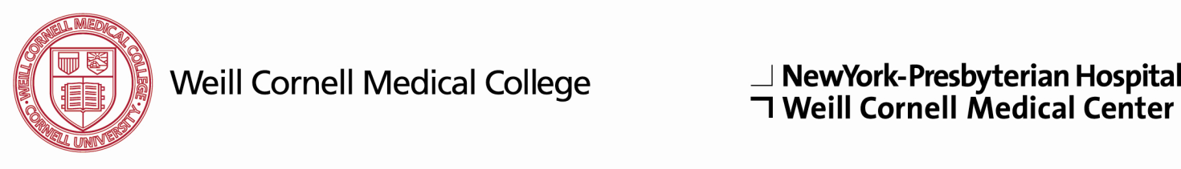

**Department of Medicine**

**NewYork-Presbyterian Hospital**

**Weill Medical College of Cornell University**

**Medical Research Track**

**Training Program**

**Name: **

**Medical School: **

**Fellowship: **

*PLEASE ANSWER QUESTIONS 1-3 SEPARATELY AND ATTACH TO THIS FORM. USE AS MUCH SPACE AS YOU NEED.*

1. **Describe the research you have conducted to date and its significance.**
2. **Describe your career plans and goals, including any research or clinical interests you may have developed. If known, please indicate the area(s) of subspecialty medicine in which you are interested.**
3. **List individuals with whom you would like to meet during your visit to NewYork-Weill Cornell in your order of interest.**
4. **Please list the individuals from whom you have requested letters of recommendation for this track. One of these letters should be from your primary research mentor/supervisor or thesis advisor for applicants who have completed a PhD, and one other individual familiar with your research.**

|  |  |  |
| --- | --- | --- |
| **Name** | **Phone Number** | **E-Mail Address** |
|  |  |  |
|  |  |  |
|  |  |  |
|  |  |  |

*PLEASE E-MAIL THIS COMPLETED FORM, ANSWERS TO QUESTIONS 1-3, AND COPIES OF YOUR RELEVANT PUBLICATIONS* ***AS ONE PDF******FILE*** *TO:*

[**nypcornell-imresidency@med.cornell.edu**](nypcornell-imresidency@med.cornell.edu)